# Introduction

This report is an analysis of the game Swords and Potions, a free to download and play third person Freemium game, with in-game purchases of additional content and features available. (Reeves 2013)

The game is set in the medieval age with the Main Character being a young merchant who owns a shop, the object being to increase the size and reputation of this by making in-game profit, through designing, making and selling merchandise to customers.

# Marketing

As the game is free to play, it is unlikely that the cost of an advertisement campaign would be covered by in-game income; consequentially it has been marketed via several online games companies and websites like Kongregate, Armour Games and Edgebee.

This method is highly reliant on good reviews posted on game forums, social media, and word of mouth, which is partially achieved by responding to both positive and negative feedback with advice, updates and software patches, evidence of which can be seen from 10th November 2013 update which increased the capacity size of resource bins from 30 units to 120 as a direct response to user comments. (Kronoan 2013).

By issuing updates the game is also kept fresh, challenging and addictive, combined with further media activity users are encouraged to repeatedly return to the game building a user community who in turn make more comments requiring more updates, which creates more activity.

# Revenue

This game relies on three types of revenues;

1. The game draws players to various websites from which the developer may receive some pay-per-click revenue.
2. There are in-game adverts which again may produce more pay-per-click revenue.
3. There are in-game purchases where the player requires tokens (Kreds) (see figure 1) as well as starter packs (A Fandom User 2012) which is a form of Endowed Progress (Conti 2016).

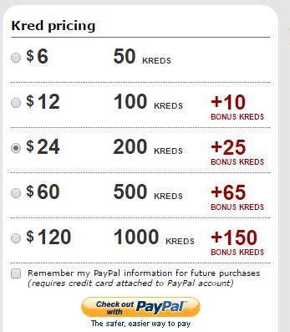

Figure

# In Game Mechanics That Drive Revenue

## Resources

When the player first enters the game they can either use a basic set of resources or add to them by purchasing starter packs, each of which allow them to increase the initial resources available.

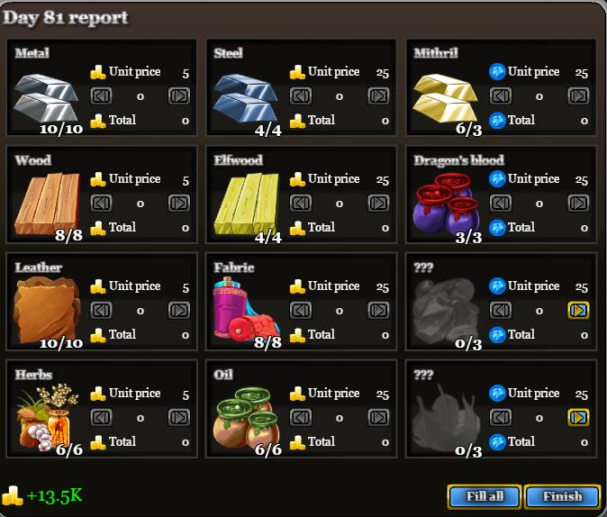These resources are divided into four categories of three ingredients of increasing rarity and price:

**Smithing:** Metal, Steel, Mithril

**Woodworking:** Wood, Elfwood, Dragon’s Blood

**Tailoring:** Leather, Fabric, Gems

**Magical:** Herbs, Oil, Mythic Feathers

During the course of the game resources are converted to items and sold for in-game currency, which can only be used to replenish resources at the end of the game day, whereas at the beginning of each new day they is a random roulette spin which grants additional resources. (Fandom User 2012)

To replenish resources during the game, tokens are used; these can either be purchased or obtained by completing quests (Fandom User 2013), and thus the cycle continues.

Figure

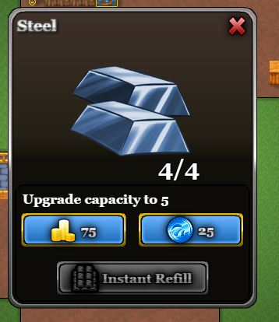

After the November 10 update, (Kronoan 2013) the player has had the option to increase the size of the resource bins from their initial size of 3 units to a maximum of 120, again by the use of in-game currency or tokens; this is known as Dual Currency (Jamornh 2012).

However once a bin reaches a capacity of thirty the cost of further increases becomes more expensive per unit, prompting Kronoan to suggests that purchasing bin capacity above 40 units was, quote “not worth it” and “the tokens can be better spent making recipes”. Others disagree with his blog, which shows this element of the game is successful in generating media noise. (Kronoan 2013)

Figure

The above similar mechanics generate revenue as the player needs to purchase tokens if they wish to progress more quickly. Whilst they can choose to use in game currency (gold) for most resources, the rarest element in each list can only be purchased, again generating revenue.

## Shop Development

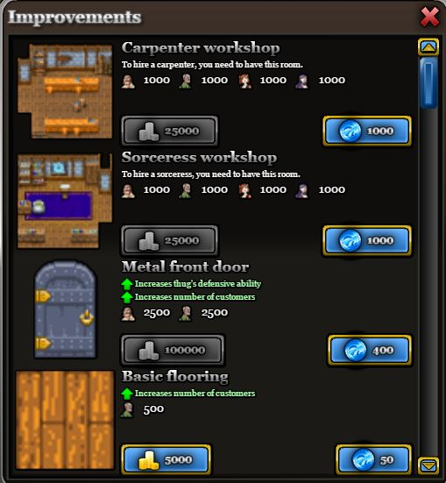Players can purchase shop improvements with in-game gold pieces or tokens, the value of which depends on the effect of the improvement.

Figure

For example, a new workshop could cost 25,000 gold pieces and would not be available to use immediately, or 1000 tokens ($120) with immediate access (A Fandom User 2015)

Other options such as a metal front door to improve security or wooden floorings to increase customer capacity, hiring staff, all cost varying amounts (A Fandom User 2015).

Once again it is possible to move through the game at a slower pace by using in-game currency only or faster by the use of purchased tokens.

## Time Limits

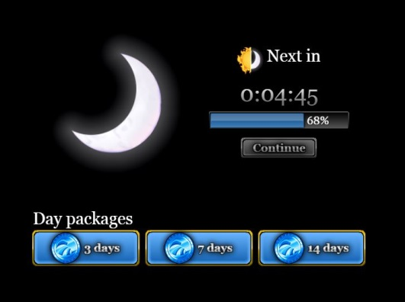Initially the player is limited to accessing the game for a fixed period in game days, at the end of which they must either wait for the available game days to replenish or purchase additional days.

This is called Time Gating (Nelson 2013) as well as Region Gating (Hauteville 2011)

There are three day packages available, three days costs 30 tokens, 7 days costs 80 tokens and 14 days costs 120 tokens.

Again a patient player can progress for free but an addicted one will spend money generating revenue which TaoGaming agrees with (TaoGaming 2011).

Figure

# Conclusion

I think the in-game resources mechanics are priced well for the initial start of the game, and they clearly state the difference in value and how they differ in rarity. It would be useful if the player could affect these prices via a sale or a two-for-one offer.

I do agree with what Kronoan says about the third column of resources being expensive and that there should be an option to pay with in-game gold as well as tokens.

I also think that the resource capacity upgrades and day packages are not value for money based on what the player gets in return, if cheaper, they would be more appealing and players would possibly make more purchases.

However the in-game Improvements Store has great appeal towards all players because it gives players options to either purchase items with gold or tokens. If the player purchases the item with tokens the build time for that item is discarded which I think is a great incentive to buying these items with token rather than gold and Kalabin thinks this also.

All in all this game appeals to those who wish to play but have limited money as well as those with more disposable income.

**Total Word Count: 976**

# References

Oxford, N. (2012). *Swords and Potions Review.* Available: <https://goo.gl/10v3o7>. (Last accessed 11th Nov 2016).

A Fandom User. (2015). *Special* *Improvements.* Available: <https://goo.gl/walnxN>. (Last accessed 11th Nov 2016).

TaoGaming. (2011). *Swords and Potions & Thoughts of Real Games.* Available: <https://goo.gl/pJcgxD>. (Last accessed 13th Nov 2016).

Kronoan. (2013). *Resources.* Available: <https://goo.gl/XW9YIf>. (Last accessed 13th Nov 2016).

A Fandom User (2012). *Resources.* Available: <https://goo.gl/XW9YIf>. (Last accessed 13th Nov 2016).

Rankin, K. (2013). *Critical Analysis Template.* Available: <https://goo.gl/38zzCf>. (Last accessed 16th Nov 2016).

Fandom User. (2012). *Starter Packs.* Available: <http://swordsandpotions.wikia.com/wiki/Starter_packs>. (Last accessed 6th Dec 2016).

G, Conti. (2016). *The Endowed Progress Effect.* Available: <https://goo.gl/0ZMeO9>. (Last accessed 6th Dec 2016).

Jamormh. (2012). *Dual Currency vs One Currency.* Available: <https://goo.gl/YDqdB8>. (Last accessed 6th Dec 2016).

Hauteville, C. (2011). *Gating.* Available: <https://goo.gl/cxO1oq>. (Last accessed 6th Dec 2016).

Nelson, B. (2013). *Optimize Time Gating in Spectrum Analysis.* Available: <https://goo.gl/AWhGQW>. Last accessed 6th Dec 2016.

Reeves, D. (2013). *Premium vs Freemium vs Subscription.* Available: <https://goo.gl/FWbuVx>. (Last accessed 6th Dec 2016).